**HIVE ASSIGNMENT**

1.creating first table

2.Loading data into the table

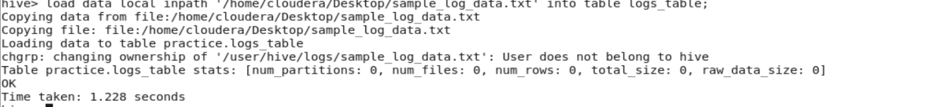

3.printing sample records to ensure that data is properly loaded into the table

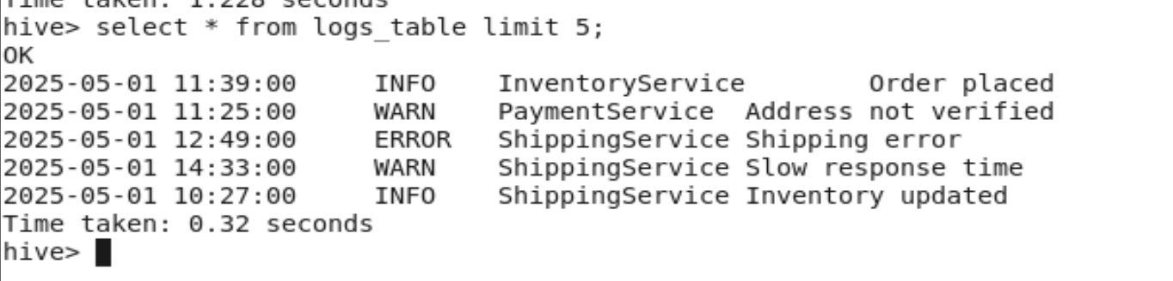

4.creating next table for partition



5.Loading data from first table to partitioned table



6.view all logs

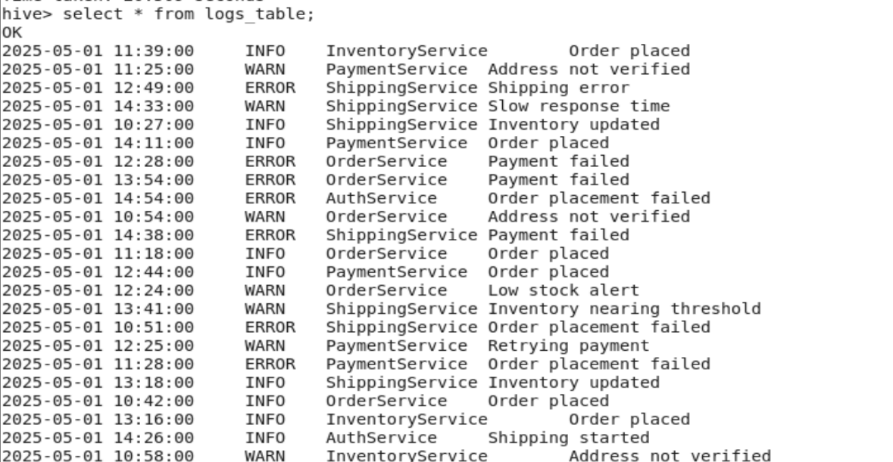

7.count total logs

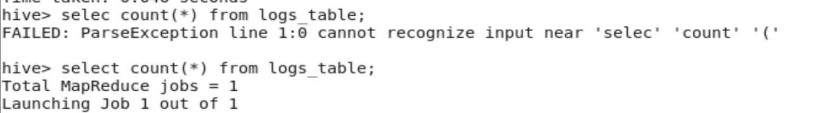

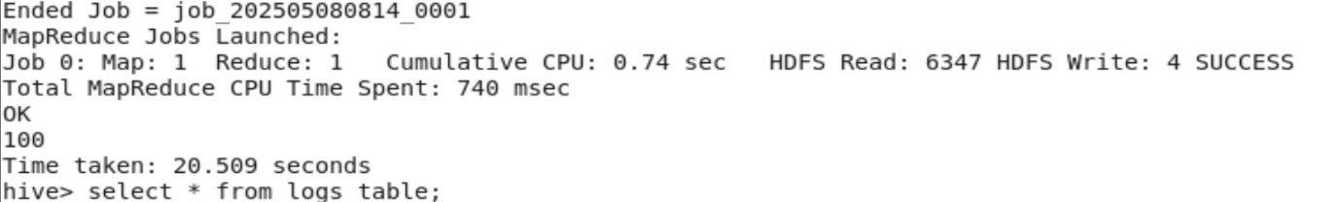

8.count logs by log level



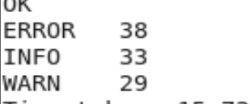

9.count error logs per service



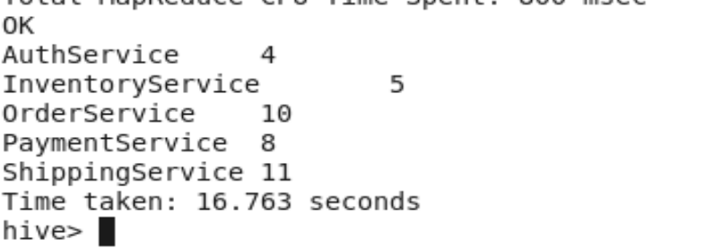

10.filter logs by date

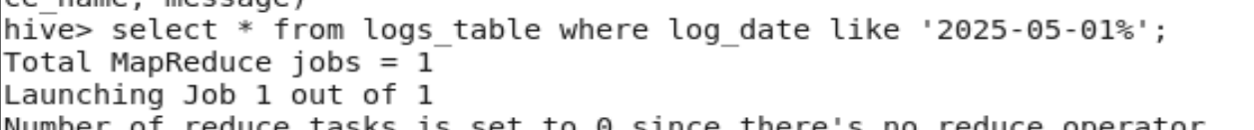

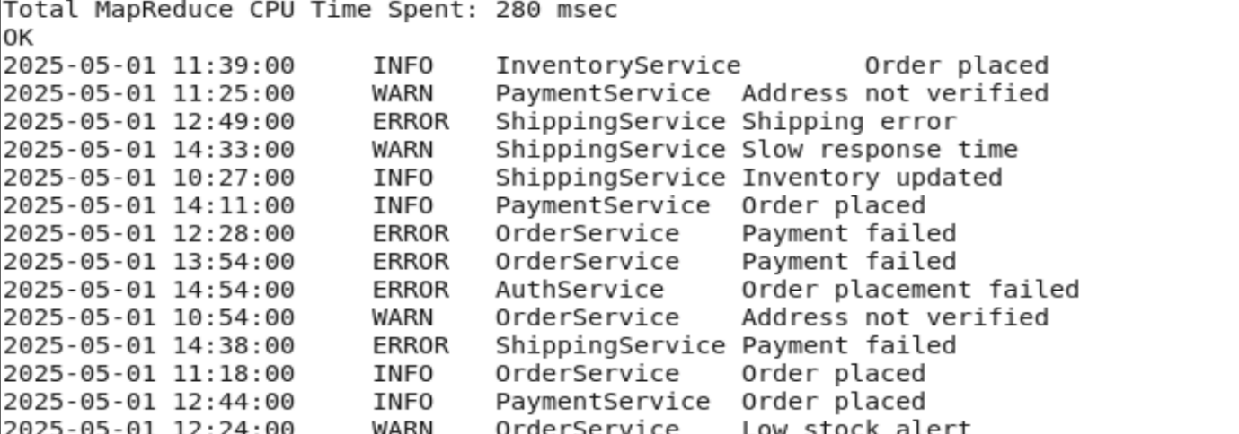

11.create view for error logs



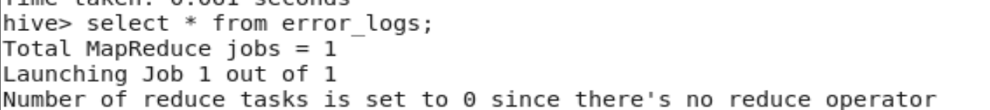

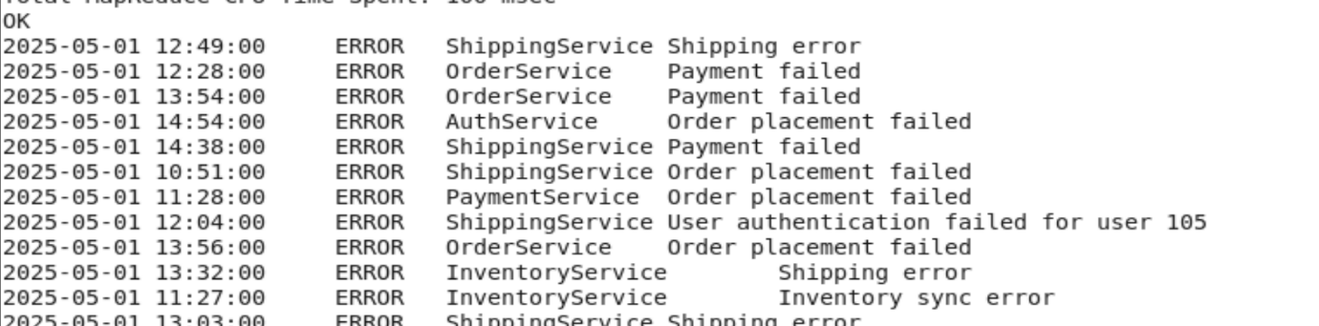

Results